User Stories of the rollups

**Date: 29.01.2025**

[**https://github.com/solana-turbin3/Rollup_SVM_Q1**](https://github.com/solana-turbin3/Rollup_SVM_Q1)

[**https://github.com/mirrorworld-universe/hypergrid-grid**](https://github.com/mirrorworld-universe/hypergrid-grid)

[**https://github.com/soonlabs**](https://github.com/soonlabs)

[**https://github.com/jito-foundation/jito-relayer**](https://github.com/jito-foundation/jito-relayer)

**https://github.com/prism-sh**

**Person: GameFi Project**

**1. User Persona**

* **Name:** Asphalt10
* **Role:** A big GameFi Project that requires a lot of cu
* **Goal:** They want to enjoy small fees and throughput

**2. User Story**

* As a GameFi project (Asphalt 10), I want to send a lot of gaming data as cheaply as possible, to maintain decentralization of my GameFi project .

**3. Acceptance Criteria**

* **Functionality:** Rollups a transaction offchain and sends the rolled transactions to the mainnet
* **User Interaction:** A gamer won’t realise the difference btw our rollup and solana mainnet
* **Security:** The rollup will be rolling the transactions with the help of SVM Api that will secure its security and putting hash of proofs to the mainnet

**4. Priority**

* **Medium**

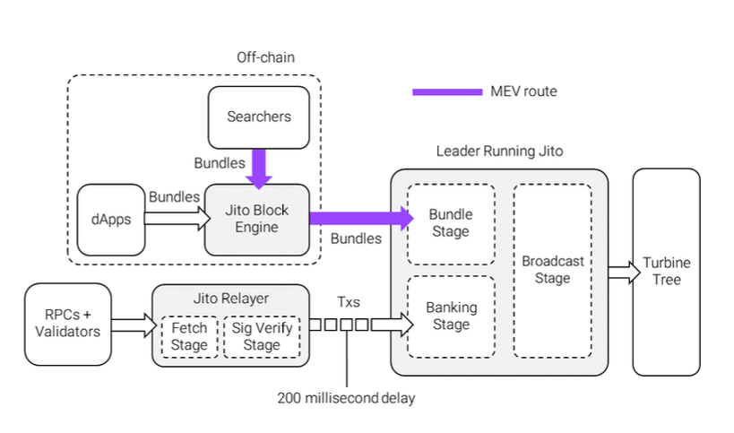

Jito inspired rollup

graph for reference:

**1. User Persona**

* **Name:** Jeff
* **Role:** Sol power user
* **Goal:** Creating their own offchain processing, similar to Jito block engine and Jito Relayer

**2. User Story**

* Jeff wants to see if he can build an alternative to the way MEV is currently conducted on Solana.

**3. Acceptance Criteria**

* **Functionality:** After a small delay, the rollup collects transactions, bundles them, and sends the rolled transactions to the mainnet
* **User Interaction:** Similar to Jito: Other network nodes remain unaware of the relayer's existence, as they send transactions to the address and port configuration the leader has advertised over the network, assuming it to be the leader’s.
* **Security:** The rollup will be rolling the transactions with the help of SVM Api that will secure its security and putting hash of proofs to the mainnet

**4. Priority**

* **Medium**

**Look into Prism! suggestion by jeff:**

**Stake-Weighted Quality of Service (SWQoS), but then on the credit rating side, where your wallet gets a credit rating.**

## **User Story L2 that could improve every L1**

## **Project Name:**

**Date:** [Date of creation]

**User Story ID:** [Unique identifier for the user story]

**1. User Persona**

* **Name:** [Give your persona a name]
* **Role:** [e.g., Advertiser, Publisher, NFT Holder]
* **Goal:** [What are they trying to achieve using the platform and its NFTs?]

Why would we want a rollup?

* improve transaction processing
* reduce costs(like trump/melania congestion)
* Gaming(magicblock/sonic)

## 

## 

## 

## 

## 

## 

## 

## 

## 

## 

## 

## 

## 

## 

## 

## 

## 

## 

## 

## 

## 

## 

## **User Story Template**

**Decentralized Advertising NFTs (PoC)**

**Project Name:** [Name of your protocol]

**Date:** [Date of creation]

**User Story ID:** [Unique identifier for the user story]

**1. User Persona**

* **Name:** [Give your persona a name]
* **Role:** [e.g., Advertiser, Publisher, NFT Holder]
* **Goal:** [What are they trying to achieve using the platform and its NFTs?]

**Example:**

* **Name:** Sarah
* **Role:** Advertiser
* **Goal:** Reach a specific target audience with my new product launch campaign.

**2. User Story**

* As a [user persona], I want to [interact with the smart contract/platform to] [perform an action] so that [I can achieve a goal].

**Example:**

* As an **Advertiser (Sarah),** I want to **mint NFTs with embedded advertising content and target specific user segments** so that **I can run a highly effective and trackable campaign.**

**3. Acceptance Criteria**

* **Functionality:** Describe the intended platform and smart contract behavior.
* **NFT Attributes:** Specify the key attributes of the advertising NFTs (e.g., targeting data, impressions, click-through tracking, royalties).
* **User Interaction:** Outline how users interact with the NFTs (e.g., viewing ads, claiming rewards, participating in campaigns).
* **Security:** Highlight security measures to protect NFTs and user data.

**Example Acceptance Criteria:**

* **Functionality:** The platform allows advertisers to create and mint NFTs with embedded ad content (images, videos, links).
* **NFT Attributes:** NFTs store targeting parameters (demographics, interests), track impressions and click-throughs, and may include revenue-sharing mechanisms via royalties.
* **User Interaction:** Publishers can display these NFTs on their websites or apps. Users who view or interact with the ads can potentially earn rewards.
* **Security:** NFTs should be verifiable and tamper-proof. User data and ad campaign performance data should be protected.

**4. Priority**

* **High/Medium/Low:** Indicate the relative importance of the user story.

**5. Technical Notes (for Developers)**

* **Dependencies:** List any other user stories or smart contract functions that this story depends on.
* **Considerations:** Outline any specific technical or design considerations.

**Example Technical Notes:**

* This story requires integration with an NFT minting and management system.
* Consider using IPFS or Arweave for decentralized storage of ad content.

**Tips for Writing Effective User Stories:**

* **Focus on the "why":** Clearly articulate the user's motivation and desired outcome.
* **Keep it concise:** User stories should be brief and easy to understand.
* **Collaborate with users:** Involve users in the process to ensure their needs are accurately captured.
* **Iterate and refine:** Regularly review and update user stories as the project evolves.